Pressure Test

Project: Imtiaz Super Store Korangi Karachi

Fire Pipe Pressure Hold
S. No | Area | Picture | Date
1 | Ground Floor | 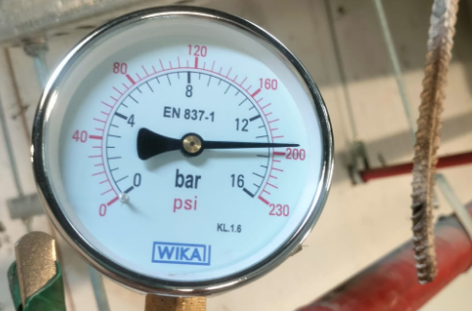 | 25 Jan 25 (12:30pm)
2 | Ground Floor | 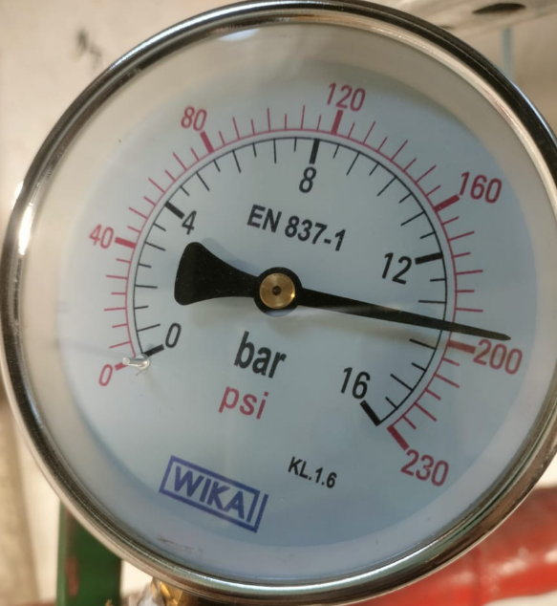 | After 24 Hours

Chilled water pipe & Valves Pressure Hold
S. No | Area | Picture | Date
1 | Riser, Ground, 1st & 2nd Floor | 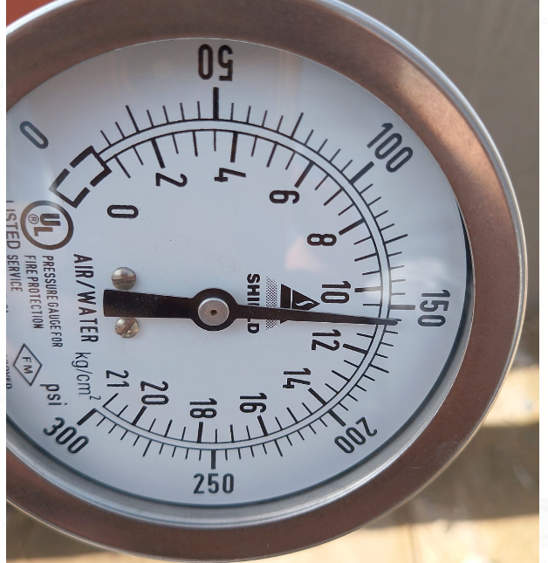 | 16 Jan 25
2 | Riser, Ground, 1st & 2nd Floor | 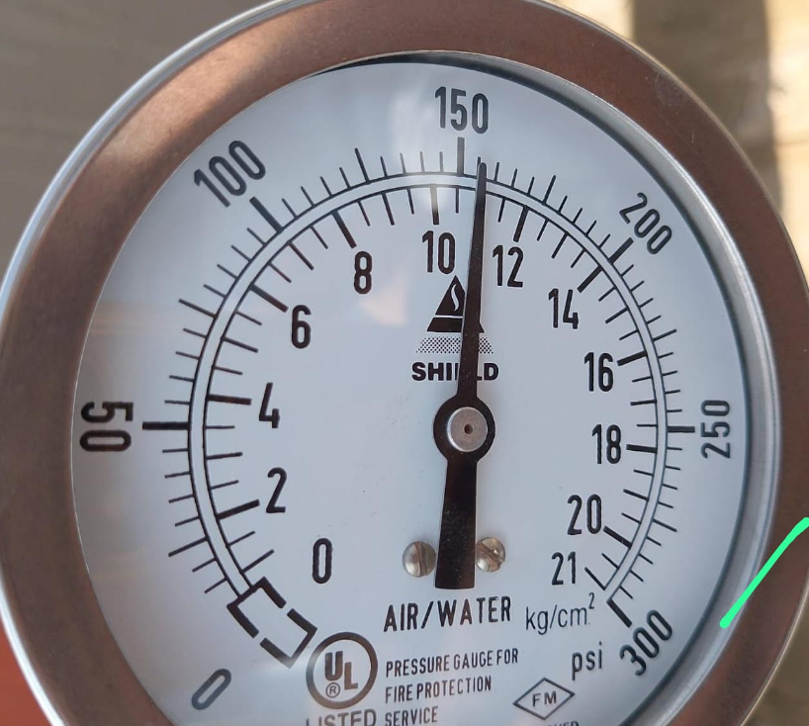 | After 24 Hours

